Document Control
Document Name | Org-BL Hierarchies PRD
Version No | 1.0
Classification | Internal
Date | 01/09/2023

Version Control
Ver No. | Author | Approved by | Approved Date | Description
1.0 | Aditya Dutta  Kanishk Tayal | Ujjwal Trivedi | 01/09/2023 | Initial Doc

ORG-BL Hierarchies PRD

Background
In every organization, the hierarchies of people within teams in different verticals is a crucial part of how various features work within WorkInSync. Onboarding employees, displaying information in the Admin Dashboard, Desk Allocation, Reports are just some of the examples that are affected depending on the way organizational hierarchy is structured.

Nomenclature
- Org-BL [Organization - Business Line]
- BL-Sub BL [Business Line - Sub-Business Line]

At the time of writing, WorkInSync supports only a two-level hierarchy with no support for further levels.

Hierarchical Structure
- An ‘org’ (organization) is a hierarchical structure. For instance, in the context of "WorkInSync," the “Technology” is an 'org'. Under that, there are divisions in the form of “Product”, “Design” called 'BLs' (Business Lines/Units).
- Teams run parallelly to this structure in a single hierarchical manner. A team does not have sub-levels and is its own separate entity.

Seat Assignment & Control
- Seats can be assigned to a particular BL. For instance, 100 seats can be assigned to the tech-product BL.
- Within this, there are roles like "MSU" that can have control over certain properties or settings. They can decide how to distribute those seats among the different BLs.
- MSU context -
  - MSU (the actual full-form isn’t known, but legend says that it is ‘Microsoft user’. Its origin is from a use case that was required for a client where there would be users who handle an account (Microsoft) that belongs to another company.
  - In this case, assume company A is a MoveInSync client.
Company A has a user who handles an entire vertical in Microsoft but works for company A. This user is an MSU and has certain admin privileges.
  - MSU Manual

Teams vs. Org
- Teams can coexist with an 'Org'. Under an 'Org' like ‘Technology’, there can be sub-teams focused on various projects.
- An employee can be part of just an 'org' and not necessarily BL.
- Currently a person has to be a part of a team when the org feature is in play. Everyone will be assigned to different orgs but a default team.

Employee Assignment
- An employee can only be part of one BL, and they can be part of only one team at a time.
- When booking resources or seats, the primary BL affiliation takes precedence. But for project purposes, their team affiliation can be used. This can lead to complexities in allocation and project management, and the use of tags help manage this scenario.

Note -
If an ‘Org’ like ‘Technology’ has four BLs with 10 people each, it doesn’t mean the total headcount for the org is 40.
Some members can exclusively belong to the org and not to any specific BL.

Enablement
- Raise an SE ticket to enable the property - “isBlSubblBuid”
- Prepare an Excel spreadsheet that has the employee data with Org & BL data.
Here is a sample -
Org-BL Sample Data
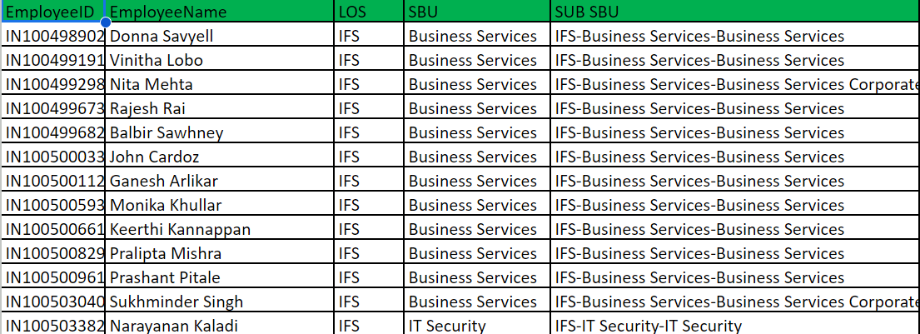
- Once the property is enabled and the file is prepared -
  - For a WiS-ETS site, it can be uploaded via the “Switch to MIS” dashboard. Head to the “Data Upload & Upload Status” tab from the top-bar. Under the Employee section, the prepared file can be uploaded. A sample file can be taken from there as well.
  - For a Stratus site, Org-BL is not supported via file upload.
  - If a client decides to enter information via a system of provisioning such as SCIM, API sync, the Org-BL data can be taken care via that mode of provisioning itself by including information in the form of attributes (SCIM) or key-value pairs (API).
Applies to Stratus and WiS-ETS sites.
- Creation of a ‘GLOBAL ADMIN' role from the Settings is required after this.
- Create a user group and then add the user that you want to assign the role of ‘GLOBAL_ADMIN’.
- Once that is done, Org/BL data will begin appearing on the Desk Allocation filters and other relevant areas.
- Example SE ticket - TO-11474 [Became a TO due a tech issue. Raise SE only]

Point of Contact
- SE Team -
  - Shruti Naik TA
  - Sindhu P
- Tech Team -
  - Pranjal Raj (config related)
  - Deepanshu (ETS dashboard related)
- Product Management team
  - Mohit Patil
  - Jovil Nazareth
  - Aditya Dutta

